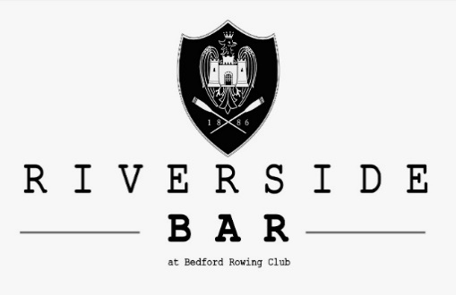

Breakfast
Menu:
Breakfast Baps:
Bacon Bap £3.50
Sausage Bap £3.50
Bacon & Sausage Bap £4.30
Add an egg for 50p
Full English Breakfast
Free tea/coffee included with Full English Breakfast:
Large £7.00
2 Sausage
2 Bacon
2 Egg (Choice of scrambled, poached, fried)
Mushrooms
Tomato
Slice of Toast (White/Brown)
Baked Beans
Black Pudding
Hash Brown

Regular £6.00
1 Sausage
1 Bacon
1 Egg (Choice of scrambled, poached, fried)
Mushrooms
Tomato
Slice of Toast (White/Brown)
Baked Beans
Black Pudding
Hash Brown

Vegetarian sausages available on request
DISHES MAY CONTAIN ALLERGENS. IF YOU HAVE DIETARY REQUIREMENTS PLEASE SPEAK TO A MEMBER OF STAFF.

